CO2-AT3-Debugging and Optimization Task
CSA0603-Desing and Analysis Of Algorithm
Name:S Priyanka
Reg no:192424033

Q26. Debugging Convex Hull Logic (Incorrect Inclusion of Interior Points)
The given brute force Convex Hull logic incorrectly accepts some interior edges as hull
edges because the validation condition is incomplete. Analyze the hull-checking logic and
identify why non-boundary segments are being included. Apply systematic debugging to
ensure that only valid outer boundary edges are selected. Optimize the checking process by
avoiding unnecessary repeated evaluations where possible. Analyze the time complexity of
the corrected brute force solution. Present a clean and structured version of the improved
logic.
def is_hull_edge(p1, p2, points):
for p in points:
val = orientation(p1, p2, p)
if val &lt; 0:
return False
return True
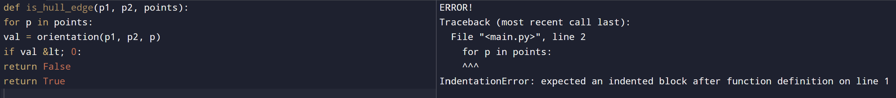
Explaination :
if val < 0:
return False
It assumes that an edge is valid if no point is on the negative side.
But it does not explicitly check whether points are present on both sides of the line.

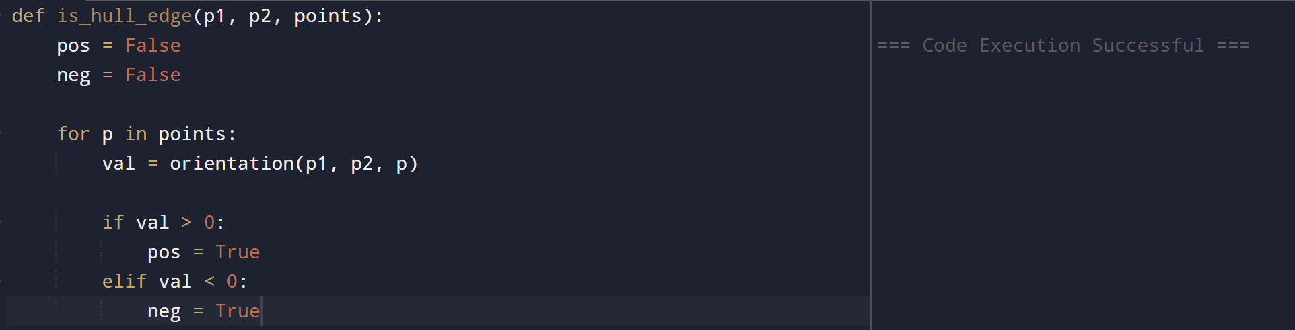
create two variables:
pos = False
neg = False
- pos = True → At least one point is on the positive side.
- neg = True → At least one point is on the negative
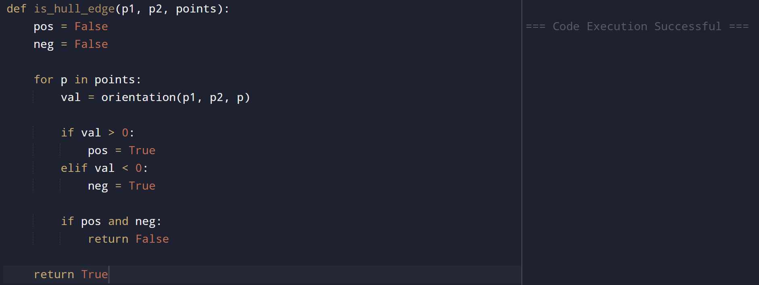
f both pos and neg become True, the points lie on both sides of the line.
Therefore, p1-p2 cannot be a convex hull edge.
Add:
if pos and neg:
return False
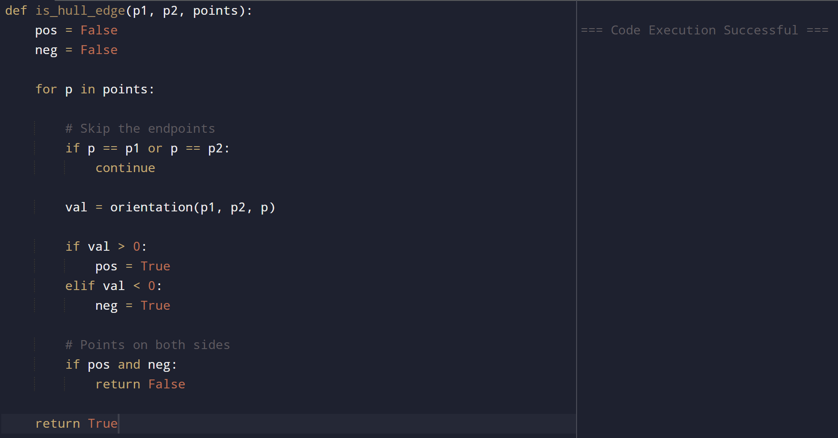
We should not check p1 and p2 themselves because they are the endpoints of the edge.
Add:
if p == p1 or p == p2:
continue
optimized code:
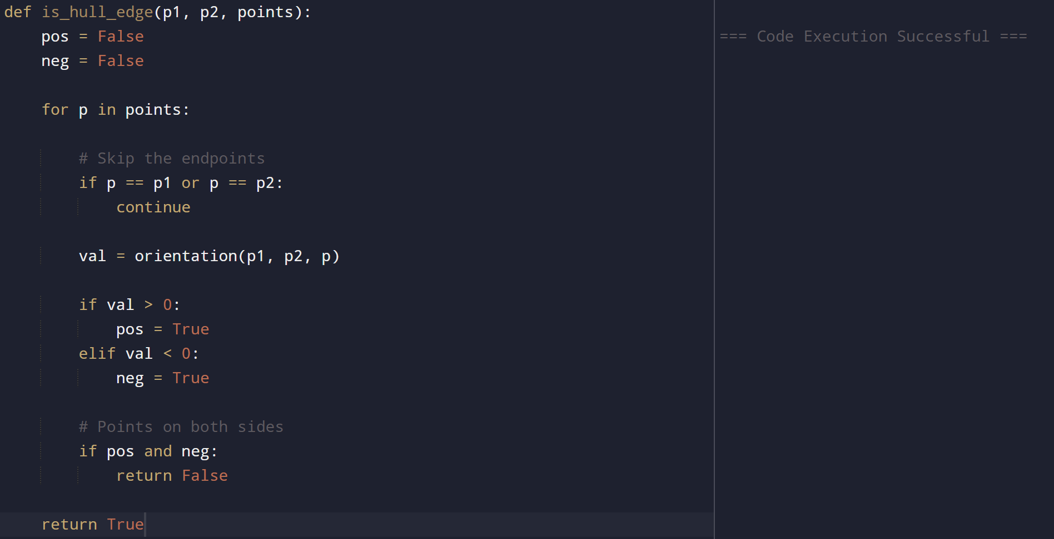
Optimization
The line:
if pos and neg:
return False
is an early termination optimization.
As soon as the algorithm finds points on both sides, it stops checking the remaining points.
Correct code:
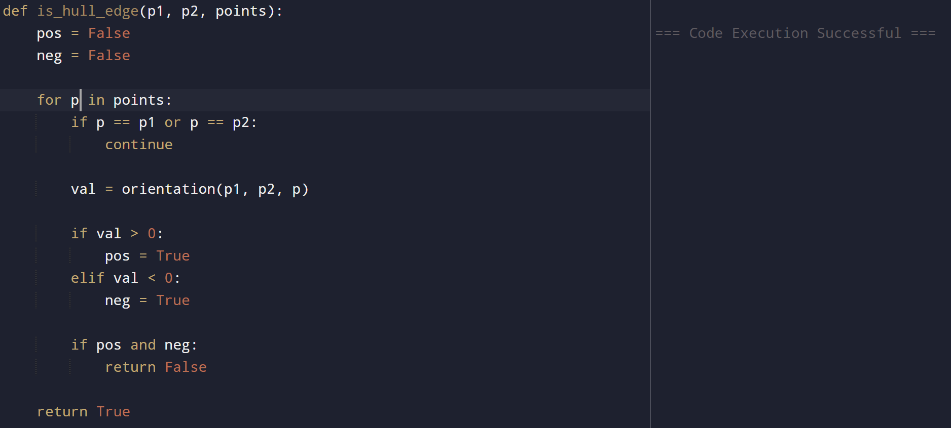
Algorithm: Corrected Brute Force Convex Hull Edge Checking
- Step 1: Start.
- Step 2: Read the number of points n and the coordinates of all points.
- Step 3: For every pair of points (Pi, Pj):
- Initialize positive = 0 and negative = 0.
- Step 4: For each remaining point Pk:
- Skip if Pk is Pi or Pj.
- Compute the orientation:
- $val=(Pj.x-Pi.x)(Pk.y-Pi.y)-(Pj.y-Pi.y)(Pk.x-Pi.x)$
- Step 5: Check the orientation:
- If val > 0, set positive = 1.
- If val < 0, set negative = 1.
- Step 6: If both positive and negative become 1:
- Reject the edge (Pi, Pj).
- Stop checking this pair (early termination).
- Step 7: If all points are on the same side (or collinear):
- Accept (Pi, Pj) as a Convex Hull edge.
- Step 8: Repeat Steps 3–7 for all pairs of points.
- Step 9: Display all valid Convex Hull edges.
- Step 10: Stop.

Complexity
Time Complexity: O(n³)
Space Complexity: O(1)

